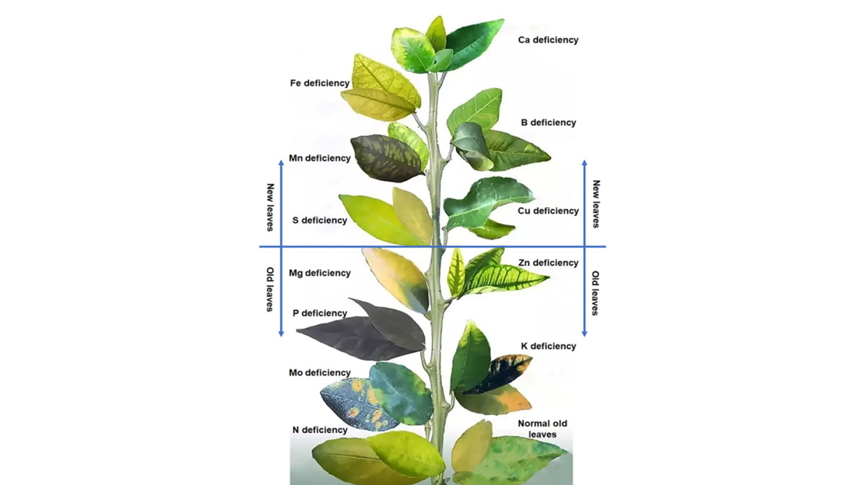

* Leaf edges/tip chlorosis
* Partial interveinal chlorosis
* Flaccid
* Partial interveinal chlorosis
* Witches broom
* Chlorotic spots
* Veinal chlorosis
* Brown/Necrotic spots
* Curling
* Die-back
* Witches broom
* Light green/Uneven chlorosis
* Brown/Black Scorching of Tips
* Die-back
* Uniform chlorosis which proceeds to young leaves
* Chlorotic spots
* Brown edges/spots
* Purple tint, purple veins
* Dark green
* Curling
* Tip die-back
* Leaf edges and tip chlorosis
* Leaf edges and tip brown
* Uniform chlorosis
* Partial interveinal chlorosis
* Grey/Necrotic spots
* Partial interveinal chlorosis followed by complete interveinal chlorosis
* Pale leaves